Writing a Paragraph
In many languages, the fundamental unit of composition is the paragraph. A paragraph consists of several sentences that are grouped together. This group of sentences together discuss one main subject. In U.S. formal academic English, paragraphs have three principal parts. These three parts are the topic sentence, body sentences, and the concluding sentence. We will also talk briefly about details in paragraphs.
The Topic Sentence
A topic sentence usually comes at the beginning of a paragraph; that is, it is usually the first sentence in a paragraph. The sentence introduces an overall idea that you want to discuss later in the paragraph.
For example, suppose that you want to write a paragraph about the natural landmarks of your hometown. The first part of your paragraph might look like this:
My hometown is famous for several amazing natural features. First, it is noted for the Wheaton River, which is very wide and beautiful. Also, on the other side of the town is Wheaton Hill, which is unusual because it is very steep.
(Notice how the first sentence begins with "My hometown..." a few spaces to the right of the paragraph edge. This is an indentation. All paragraphs in English MUST begin with an indentation.)
(Again, note how this paragraph is indented on the first line, about five or seven spaces in from the left-hand edge of the paragraph. Always remember to indent your paragraphs!)
Supporting Sentences or Details
Consider again the above-mentioned, short paragraph:
My hometown, Wheaton, is famous for several amazing natural features. First, it is noted for the Wheaton River, which is very wide and beautiful. Also, on the other side of the town is Wheaton Hill, which is unusual because it is very steep.
When a reader reads a topic sentence, such as My hometown, Wheaton, is famous for several amazing natural features,a question should usually appear in the reader's mind. In this case, the question should be like, "What are the natural features that make Wheaton famous?" The reader should then expect that the rest of the paragraph will give an answer to this question.
Now look at the sentences after the topic sentence. We can see that the second sentence in the paragraph, First, it is noted for the Wheaton River, which is very wide and beautiful,indeed gives an answer to this question. That is, the second sentence gives some explanation for the fact that Wheaton is a famous town. Similarly, we can see that the third sentence also gives some explanation for the fact that Wheaton is famous by giving another example of an "amazing natural feature," in this case, Wheaton Hill.
The second and third sentences are called supporting sentences. They are called "supporting" because they "support," or explain, the idea expressed in the topic sentence. Of course, paragraphs in English often have more than two supporting ideas. The paragraph above is actually a very short paragraph. At minimum, you should have at least five to seven sentences in your paragraph. Here we can see our paragraph about Wheaton with a few more supporting sentences in bold font:
My hometown is famous for several amazing natural features. First, it is noted for the Wheaton River, which is very wide and beautiful. Also, on the other side of the town is Wheaton Hill, which is unusual because it is very steep. The third amazing feature is the Big Old Tree. This tree stands two hundred feet tall and is probably about six hundred years old.
In this lesson, we will talk about supporting sentences again in the section, "Details in Paragraphs," below.
The Concluding Sentence
In formal paragraphs you will sometimes see a sentence at the end of the paragraph which summarizes the information that has been presented. This is the concluding sentence. You can think of a concluding sentence as a sort of topic sentence in reverse.
You can understand concluding sentences with this example. Consider a hamburger that you can buy at a fast-food restaurant.* A hamburger has a top bun (a kind of bread), meat, cheese, lettuce, and other elements in the middle of the hamburger, and a bottom bun. Note how the top bun and the bottom bun are very similar. The top bun, in a way, is like a topic sentence, and the bottom bun is like the concluding sentence. Both buns "hold" the meat, onions, and so on. Similarly, the topic sentence and concluding sentence "hold" the supporting sentences in the paragraph. Let's see how a concluding sentence (in bold font) might look in our sample paragraph about Wheaton:
My hometown is famous for several amazing natural features. First, it is noted for the Wheaton River, which is very wide and beautiful. Also, on the other side of the town is Wheaton Hill, which is unusual because it is very steep. The third amazing feature is the Big Old Tree. This tree stands two hundred feet tall and is probably about six hundred years old. These three landmarks are truly amazing and make my hometown a famous place.
Notice how the concluding sentence, These three landmarks are truly amazing and make my hometown a famous place,summarizes the information in the paragraph. Notice also how the concluding sentence is similar to, but not exactly the same as, the topic sentence.
Not all academic paragraphs contain concluding sentences, especially if the paragraph is very short. However, if your paragraph is very long, it is a good idea to use a concluding sentence.
Details in Paragraphs
Why are details important? Consider the example of the hamburger, mentioned above.* If the hamburger buns are the topic and concluding sentences, then the meat, the cheese, the lettuce, and so on are the supporting details. Without the food between the hamburger buns, your hamburger would not be very delicious! Similarly, without supporting details, your paragraph would not be very interesting.

Assignment
Directions: Read each paragraph. Next Underline the Topic Sentence, Circle all of the Supporting Details, and Double Underline the Concluding Sentence –
Next use the Paragraph to fill in the Hamburger Paragraph Organizer.

If I were president, I’d be responsible. I’d look alert and run the United States like it should be run. I’d be honest. Then the people would trust me. I would be a good president because I have faith in the people of the United States.
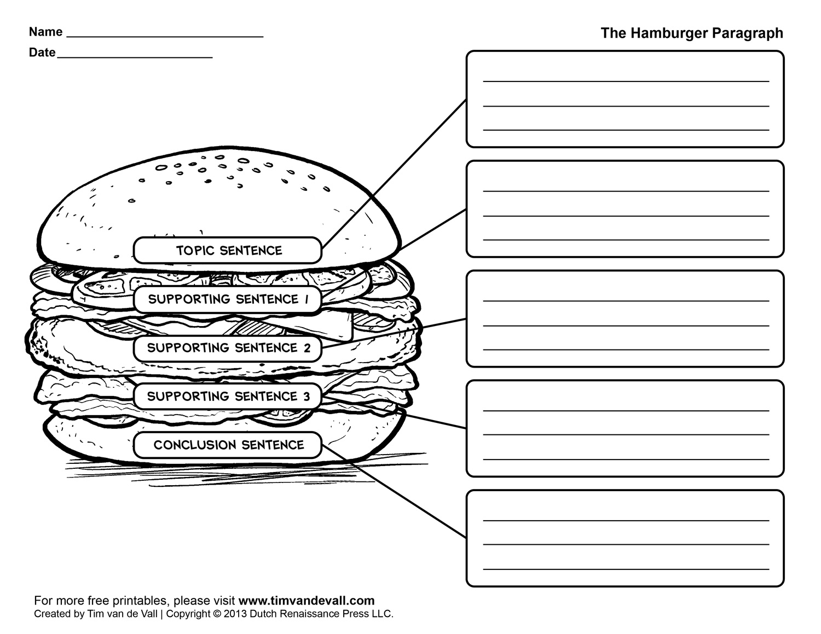

Directions: Read each paragraph. Next Underline the Topic Sentence, Circle all of the Supporting Details, and Double Underline the Concluding Sentence –
Next use the Paragraph to fill in the Hamburger Paragraph Organizer.
Robots are being used in sumo wrestling contests. Sumo wrestling is a sport that started in Japan. It takes place in a ring. Two players try to score points by holding each other down or pushing each other out of the ring. Robot sumo uses robots instead of humans. The robot that scores the most points wins. Robots play an important role in wrestling contests.

Directions: Read each paragraph. Next Underline the Topic Sentence, Circle all of the Supporting Details, and Double Underline the Concluding Sentence –
Next use the Paragraph to fill in the Hamburger Paragraph Organizer.

Mother gorillas do a lot for their babies. They nurse their babies. They protect them from danger. And they teach the tiny gorillas how to get along with other gorillas. These are just a few things that mother gorillas do.

Assignment 2
Directions: Use the Hamburger Graphic Organizer to write a paragraph using the following topic sentence:

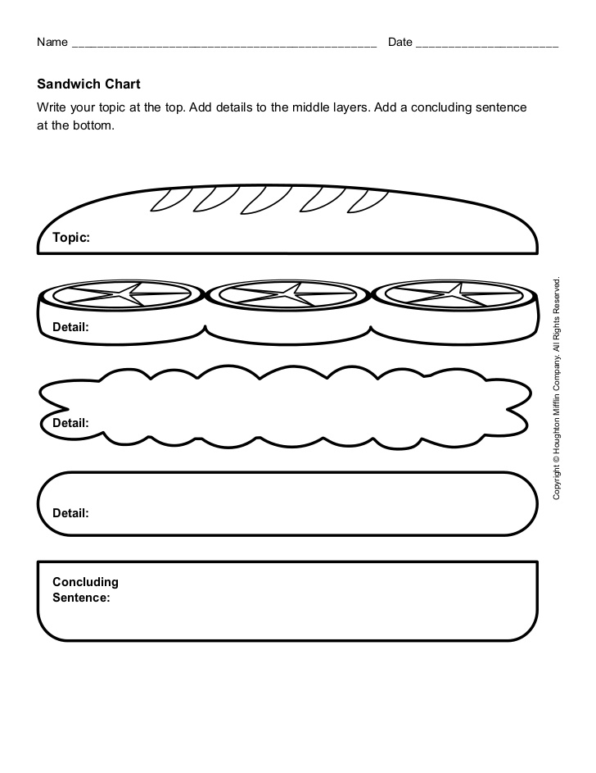
If I were an animal I would be a ________

